MELTEM ÇAP-201504056

-Consider a continuus - time signal x(t)=3cos(2πt) + 2sin(4πt)

1)Sketch the waveform of x(t) over one period

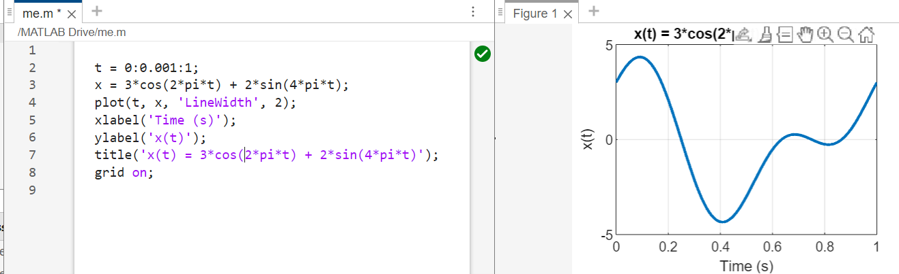

Descriptions:

**t = 0:0.001:1;** //Here, a time interval is determined, starting from 0 and increasing every 0.001 seconds up to 1 second. This represents the time interval over which the signal will be plotted.

**x = 3*cos(2*pi*t) + 2*sin(4*pi*t);** //First, using the time interval (t) we defined, the values of the signal are calculated with cosine and sine functions.

**plot(t, x, 'LineWidth', 2);** // In this line, the calculated signal is plotted. Time (t) and signal (x) data are plotted using the plot function.

**xlabel('Time (s)');** // This line determines the label of the x-axis. It is labeled 'Time (s)' because it shows time expressed in seconds on the x-axis.

**ylabel('x(t)');** // This line determines the label of the y-axis. It is labeled 'x(t)' because it shows the values of the signal on the y-axis.

**title('x(t) = 3*cos(2*pi*t) + 2*sin(4*pi*t)');** //This line determines the title of the chart. The header contains the mathematical formula of the signal.

2)Determine the frequency components present in x(t).

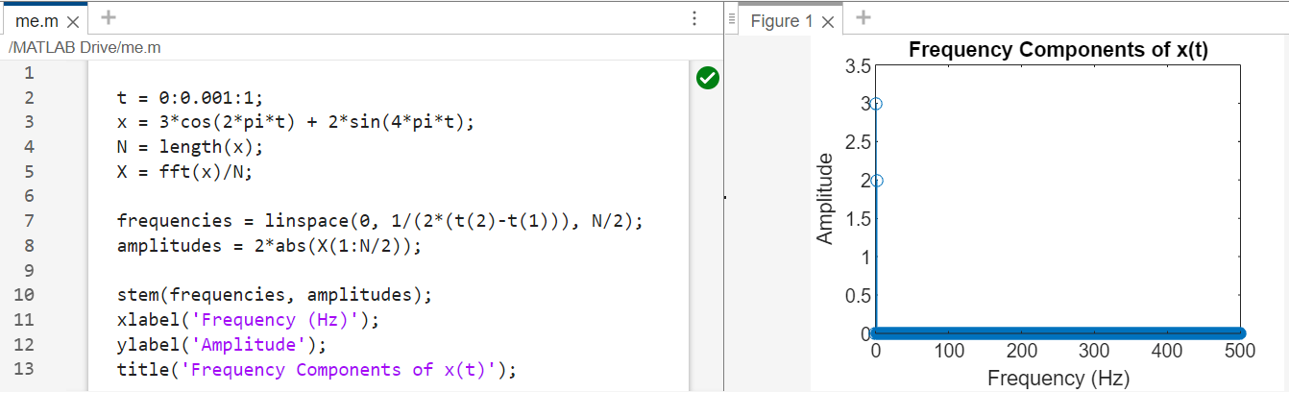

Descriptions

This code takes the FFT(***Fast Fourier Transform***)of the signal and then calculates and plots the frequency components of the signal using the FFT results. The fft function is used to calculate FFT. The frequency range is determined with the linspace function. Absolute values of FFT results are taken with the abs function. Finally, frequency components are plotted with the stem function.

3)Compute the average power of x(t) over one period.

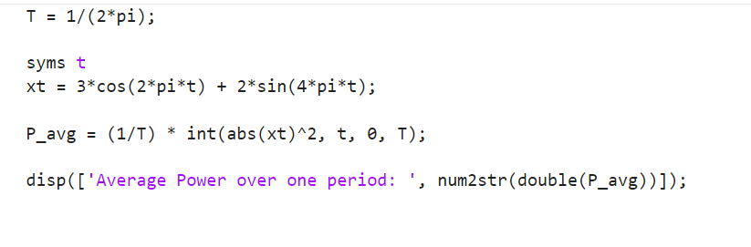Descriptions

% Define the period of the signal //T = 1/(2*pi);

% Signal is defined as x(t) = 3*cos(2*pi*t) + 2*sin(4*pi*t)

% Calculate the average power over a period P Avg = (1T) * int(abs(xt)^2, t, 0, T).

- Given the discrete - time signal x[n] ={1,-2,3,-4,5}:

1)Determine the length of the signal. =5

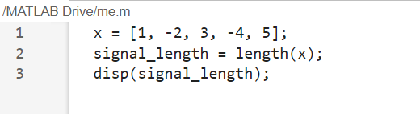

2)Find the value of x[3]. =3

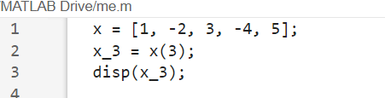

3)Compute the sum of all elements in the signal. =3

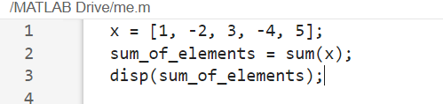

4) Calculate the energy of the signal. =55

